Ontogenetic and temporal variations in diets of the marbled flounder, Pseudopleuronectes yokohamae in the mid-western coast of Korea

Joo Myun Park^{1,2*}, Seok Nam Kwak², Sung-Hoi Huh³, Laith A. Jawad⁴, Ralf Riedel⁵

¹Department of Biological Sciences, Macquarie University, Sydney, NSW 2109, Australia
²Environ-Ecological Engineering Institute Co., Ltd., Busan 613-827, Korea
³Department of Oceanography, Pukyong National University, Busan 608-737, Korea

⁴Flat Bush, Manukau, Auckland, New Zealand

⁵S&R Consultancy, Ocean Springs, Mississippi, USA

Running Head: Dietary variations of Pseudopleuronectes yokohamae

*Corresponding author: Joo Myun Park, Department of Biological Sciences, Macquarie University, Sydney, NSW 2109, Australia; phone: +61 2 9850 8234; e-mail: joomyun@gmail.com

Abstract
Stomach contents of Pseudopleuronectes yokohamae collected from mid-western coast of Korea were analyzed to determine dietary composition and ontogenetic and temporal dietary variations. The total length (TL) of the specimens was 8.6–26.8 cm. P. yokohamae is a bottom-feeding carnivore that primarily consumes polychaetes and secondarily consumes amphipods, ophiuroids and bivalves, but also eats various benthic crustaceans and invertebrates with small amounts. Although polychaetes dominated the diet of both smaller and larger fishes, ophiuroids and bivalves were more frequently consumed by larger specimens. The results of distance-based linear modeling (DISTLM) revealed that the diets compositions of P. yokohamae varied significantly with respect to maturity and total length (TL), but did not relate with month, water temperature and sex. The results indicated that P. yokohamae foraged primarily in polychaetes, thus a little dietary variations was evident.

Key words: Stomach contents, marbled flounder, polychaetes, mid-western Korea

Introduction
The marbled flounder, Pseudopleuronectes yokohamae (Günther, 1887), is a benthic flatfish (Pleuronectiformes; Pleuronectidae) widely distributed throughout temperate waters in the western Pacific. This species inhabits sandy and muddy bottoms in coastal habitats (Yamada et al., 1986; NFRDI, 2004). Pleuronectidae fishes (righteye flounders) constitute 103 species in 40 genera distributed worldwide (Froese and Pauly 2015), with more than 26 species in Korean waters (Kim et al. 2005). All of the species of this family are demersal. Fishes of this family have a flattened body, a pale underside, and ventrally located eyes, which make them well adapted to the benthic environment.
Righteye flounders, including P. yokohamae, are commercially important in Korea (NFRDI 2004), where they are primarily caught in gillnets and trawls (KOSTAT 1990–2015). In the western sea of Korea, commercial landings of righteye flounders comprised mainly of Kareius bicoloratus, Pleuronichthys cornutus, and P. yokohamae this latter the most abundant in weight (Cha et al., 2013; Kim et al., 2013; Park et al., 2013). P. yokohamae is also ecologically important, due to its high abundance throughout its habitats (Park et al., 2013; Jeong et al., 2014).
Due to the commercial and ecological importance of P. yokohamae, many studies about its ecology and biology have been conducted. Results of studies on dietary habits of juvenile (Kwak and Huh, 2003) and adult (Huh et al., 2012), early life history (Moon and Lee, 1999; Joh et al., 2005), growth (Kim et al., 2015) and reproduction (Tanda et al., 2008; Seo et al., 2010) have been used in conservation and management of this species. Righteyed flounders are considered benthic invertebrate feeders that occupy intermediate trophic levels (Froese and Pauly 2015). Studies on the feeding ecology of P. yokohamae may shed light on the functional role of this species in marine ecosystems (Wootton 1990; Brodeur and Pearcy 1992), providing additional insight for management and conservation (Micheli and Halpern 2005; Greenstreet and Rogers 2006). More specifically, studies on dietary changes with fish size and studies on diet patterns with space may further provide management with information on ecological linkages and data on stock structures, respectively, for this species.
The objectives of this study were to determine dietary composition of P. yokohamae and to identify diet patterns with fish size, time of year, gender, and water temperature. The results from this study will contribute to management and conservation of this species in Korean waters.

Materials and methods
Study area and sampling
Fishing grounds located on the eastern part of Yellow Sea which is a semi-enclosed shallow sea with depths of <100 m, and off the middle western coast of Korea (36°25′N∼37°00′N, 126°00′E∼126°20′E; see also Baeck et al., 2011a). The study area serves as habitat for many commercially significant benthic fishes such as Lophius litulon, Okamejei kenojei and Paralichthys olivaceus (NFRDI 2004).
Sampling was performed each month from April to July 2008. Fish were collected at depths of 20–30 m using a small bottom trawl (length 20 m, width 4 m, mesh wing and body 3 cm, mesh liner 1 cm). Trawl netting was performed during daylight at neap tides. Immediately after capture, fish were packed in ice and transported to the Pukyong National University. In the laboratory, total length (TL) and wet weight were measured to the nearest millimetre and nearest gram, respectively. Stomachs were removed and the contents preserved in 5% formalin at least 24 hours, and transferred to 70% isopropanol for storage.

Stomach content analysis
All prey items were identified to the lowest possible taxonomic level. The unidentifiable prey items and partly digested material were categorised at higher taxonomic levels. Although most of the prey items were intact, some fragments were collected and considered to be parts of a single prey item (prey counts included these collected fragmentary items). We found no evidence of regurgitation. The prevalence of each prey item was quantified with the aid of a dissecting microscope. The numbers and wet weights of each prey item were recorded.
To infer whether there were any size-related and seasonal trends in the dietary composition, samples were divided into two maturity groups (immature and mature) based on their maturity size (Seo et al., 2010) and four months (April, May, June and July). Thus, for the analyses, the maturity groups were grouped as immature (14.0–19.9 cm TL, n=59) and mature (20.0–40.6 cm TL, n=149), the four months as April (n=42), May (n=59), June (n=43) and July (n=64).
Diet was quantified by frequency of occurrence (%F = 100×A_{i}×N⁻¹), as a numerical percentage (%N = 100×N_{i}×N_{T}⁻¹), and as a mass percentage (%W = 100×W_{i}×W_{T}⁻¹), where A_{i} was the number of fish preying on species i, N is the total number of fish examined (excluding those with empty stomachs), N_{i} (W_{i}) is the number (weight) of prey individuals i, and N_{T} (W_{T}) is total number (weight) of prey individuals. Next, the index of relative importance (I_{RI}) (Pinkas et al., 1971) was calculated for each prey item as follows: I_{RI} = (%N+%W)×%F, and expressed as a percentage (%I_{RI}).
Cumulative prey curves were constructed by randomizing the stomach order 10 times and by plotting the mean numbers of 11 prey taxa (amphipods, bivalves, crabs, carid shrimps, cumaceans, gastropods, isopods, ophiuroids, polychaetes, sipunculid worms, stomatopods, tannids) against the number of stomachs analyzed (Ferry and Cailliet 1996). Attainment of an asymptote indicated that an adequate number of stomachs were studied. A curve was considered to asymptote if at least ten previous values of the total number of prey taxa were in the range of the asymptotic number of prey ±0.5 (Huveneers et al. 2007). Cumulative curves were drawn by reference to all of the specimens.

Dietary change analysis
To examine the relative extents to which potential predictors explained most of the variability in dietary composition, distance-based linear modeling (DISTLM) was employed (Anderson et al., 2008; Dunn, 2009). The gravimetric data were first square root transformed to avoid any tendency for the main dietary components to be excessively dominant (Platell and Potter 2001), and then Bray–Curtis dissimilarity matrices were constructed. DISTLM performs multivariate multiple regression based on a given distance measure to model the relationship between multivariate data and one or more predictor variables. The potential predictors were total length, maturity, month, water temperature and sex. Total length and water temperature were considered continuous variables, and maturity, month and sex were considered a categorical variable. DISTLM produces both a marginal test, which assesses how much variation is explained by each predictor when taken alone (ignoring all other variables), and a conditional test, which assesses how much is explained by all of the variables (Anderson et al., 2008). A conditional test was performed using a forward selection of the predictors, using permutation tests on the R² criterion (Anderson et al., 2008). The most parsimonious model were identified using the Akaike Information Criterion (AIC), because R² simply increases with an increasing number of predictors (Anderson et al., 2008).
SIMPER was used to estimate the contribution of each prey taxa to any significant differences in the diets by each of categorical variable (i.e. maturity and month) that were identified by DISTLM. The cut off in SIMPER for prey taxa to be reported was chosen to be a cumulative contribution of 90%. DISTLM and SIMPER were performed using the routines in the PRIMER v6 multivariate statistics package (www.primer-e.com) and the PERMANOVA+ add-on module (Anderson et al., 2008).

Results
Overall dietary composition
A total of 208 P. yokohamae specimens of 14.0–40.6 cm TL (mean ± SD = 23.5 ± 5.3 cm) were collected during the study period. Of the 208 stomachs, 13 (6.25%) were empty. Cumulative prey curves for overall diet (number of prey taxa found) attained asymptotes after ~146 stomachs (Fig. 2). Thus, the sample sizes were enough to allow us to adequately describe the diet of P. yokohamae in the study area.

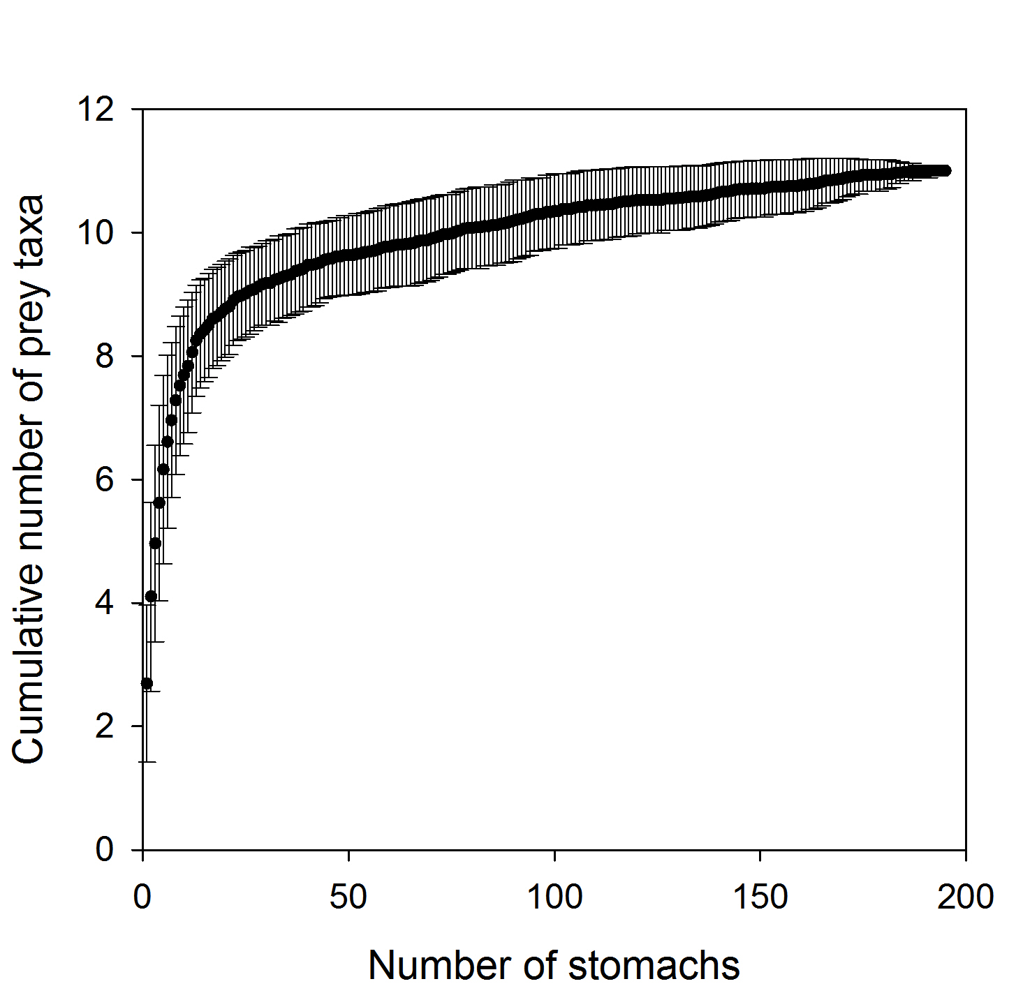
Fig. 1. Cumulative prey curves (prey taxa per stomach) for Pseudopleuronectes yokohamae collected in the mid-western coast of Korea. Error bars represent standard deviations.

A total of 11 prey taxa were found in the 195 stomachs with content (Table 1). Polychaetes were the most common prey item, consisting of 96.4% by occurrence, 63.6% by number, 76.8% by weight, and 88.2% in IRI. At least 27 polychaete species were identified. Ampharetidae and Lumbrineridae polychaetes, including Ampharete arctica, Lumbrineris heteropoda, L. japonica, L. longifolia, were the principal prey items, having a total weight of 45.4%. Amphipods were the second-largest dietary component, totalling 44.6% by occurrence, 19.0% by number, 0.6% by weight, and 5.4% in IRI. Both ophiuroids and bivalves made up each of 2.6% in IRI, and all of remaining prey taxa constituted less than 1.0% in IRI.

Table 1 Stomach contents Pseudopleuronectes yokohamae showing frequency of occurrence, number, weight, and index of relative importance (IRI)
Prey taxa |  |  | %F | %N | %W | %IRI
SIPUNCULA
Sipunculida |  | Unidentifided | 1.0 | 0.1 | <0.1 | <0.1
ECHINODERMATA
Ophiuroidea |  | Unidentifided | 27.2 | 6.6 | 8.0 | 2.6
MOLLUSCA
Bivalvia |  | Unidentifided | 34.4 | 3.8 | 7.8 | 2.6
Gastropoda |  | Unidentifided | 12.3 | 1.6 | 3.0 | 0.4
ANNELIDA
Polychaeta |  | Total | 96.4 | 63.6 | 76.8 | 88.2
 |  | Arenicolidae sp. | 2.6 | 0.4 | 0.2
 |  | Ampharete arctica | 20.5 | 3.3 | 3.3
 |  | Ampharetidae spp. | 71.3 | 33.1 | 34.8
 |  | Aphroditidae sp. | 1.5 | 0.1 | 1.5
 |  | Brada villosa | 1.0 | 0.1 | <0.1
 |  | Cirratulus cirratus | 1.0 | 0.1 | <0.1
 |  | Eunicidae sp. | 7.2 | 0.6 | 3.0
 |  | Glycera chirori | 28.2 | 2.6 | 7.4
 |  | Heteromastus filiformis | 3.1 | 0.2 | 0.1
 |  | Lagis bocki | 4.1 | 0.4 | 0.6
 |  | Lumbrineris heteropoda | 3.6 | 0.5 | 2.9
 |  | Lumbrineris japonica | 10.3 | 1.0 | 0.7
 |  | Lumbrineris longifolia | 34.4 | 12.3 | 7.0
 |  | Maldanidae sp. | 1.5 | 0.1 | 0.1
 |  | Nephtys polybranchia | 2.1 | 0.2 | 0.1
 |  | Nereidae sp. | 1.0 | 0.1 | <0.1
 |  | Onuphidae sp. | 10.8 | 2.8 | 2.0
 |  | Paralacydonia paradoxa | 3.1 | 0.2 | 0.1
 |  | Phyllodocidae sp. | 2.1 | 0.2 | <0.1
 |  | Polycnoidae sp. | 8.2 | 0.8 | 4.3
 |  | Sabellidae sp. | 1.0 | 0.1 | 0.1
 |  | Sigalionidae sp. | 3.6 | 0.3 | 0.2
 |  | Sigambra tentaculata | 0.5 | 0.0 | <0.1
 |  | Spionidae sp. | 1.5 | 0.1 | 0.1
 |  | Sternaspis scutata | 2.6 | 0.2 | 4.4
 |  | Syllidae sp. | 4.1 | 0.4 | 0.1
 |  | Terebellidae spp. | 17.4 | 2.9 | 3.6
 |  | Unidentified Polychaeta | 4.6 | 0.5 | 0.2
CRUSTACEA
Amphipoda |  | Gammaridea Total | 44.6 | 19.0 | 0.4 | 5.7
 |  | Amphithoe spp. | 2.1 | 0.2 | 0.1
 |  | Byblis japonicus | 2.6 | 0.3 | <0.1
 |  | Corophium sp. | 0.5 | <0.1 | <0.1
 |  | Jassa falcata | 1.0 | 0.1 | <0.1
 |  | Liljeborgia japonicus | 1.0 | 0.1 | <0.1
 |  | Monoculodes sp. | 1.0 | 0.1 | <0.1
 |  | Unidentified Gammaridea | 42.6 | 18.2 | 0.3
Isopoda |  | Total | 14.9 | 2.2 | 1.0 | 0.3
 |  | Idoteidae sp. | 11.8 | 1.6 | 0.8
 |  | Unidentified Isopoda | 5.6 | 0.6 | 0.1
Cumacea |  | Unidentifided | 13.8 | 1.3 | 0.1 | 0.1
Stomatopoda |  | Unidentifided | 0.5 | 0.0 | 0.2 | <0.1
Decapoda
 | Caridea | Total | 5.1 | 0.4 | 0.4 | <0.1
 |  | Alpheidae spp. | 1.5 | 0.1 | 0.3
 |  | Crangonidae spp. | 1.0 | 0.1 | <0.1
 |  | Latretus planirostris | 0.5 | <0.1 | <0.1
 |  | Leptochela gracilis | 0.5 | <0.1 | <0.1
 |  | Unidentified Caridea | 1.0 | 0.1 | <0.1
 | Brachyura | Total | 15.4 | 1.4 | 2.4 | 0.4
 |  | Leucosiidae sp. | 0.5 | 0.0 | <0.1
 |  | Ocypodidae sp. | 0.5 | 0.1 | 0.6
 |  | Paradorippe granulata | 0.5 | 0.2 | 0.2
 |  | Pinnotheridae sp. | 4.6 | 0.2 | 1.0
 |  | Unidentified Brachyura | 10.3 | 0.8 | 0.5

Variations in diets
When the dietary data were examined by size class, polychaetes were comprised mostly in the diets of both maturity groups. However, there also was some difference in dietary composition between immature and mature groups. Smaller P. yokohamae fed mainly on polychaetes, and the contribution of polychaetes declined as the body size of this predator increased (Fig. 2a). In contrast, the contribution of bivalves, ophiuroids, and crustaceans became greater with increasing body size of P. yokohamae. In terms of month, the diets of P. yokohamae in all months were dominated by polychaetes, with some tendency for the bivalve and ophiuroids to increase in May and June (Fig. 2b). Crustaceans showed increased consumption in May and June, but the contributions were less than 4% during other months.

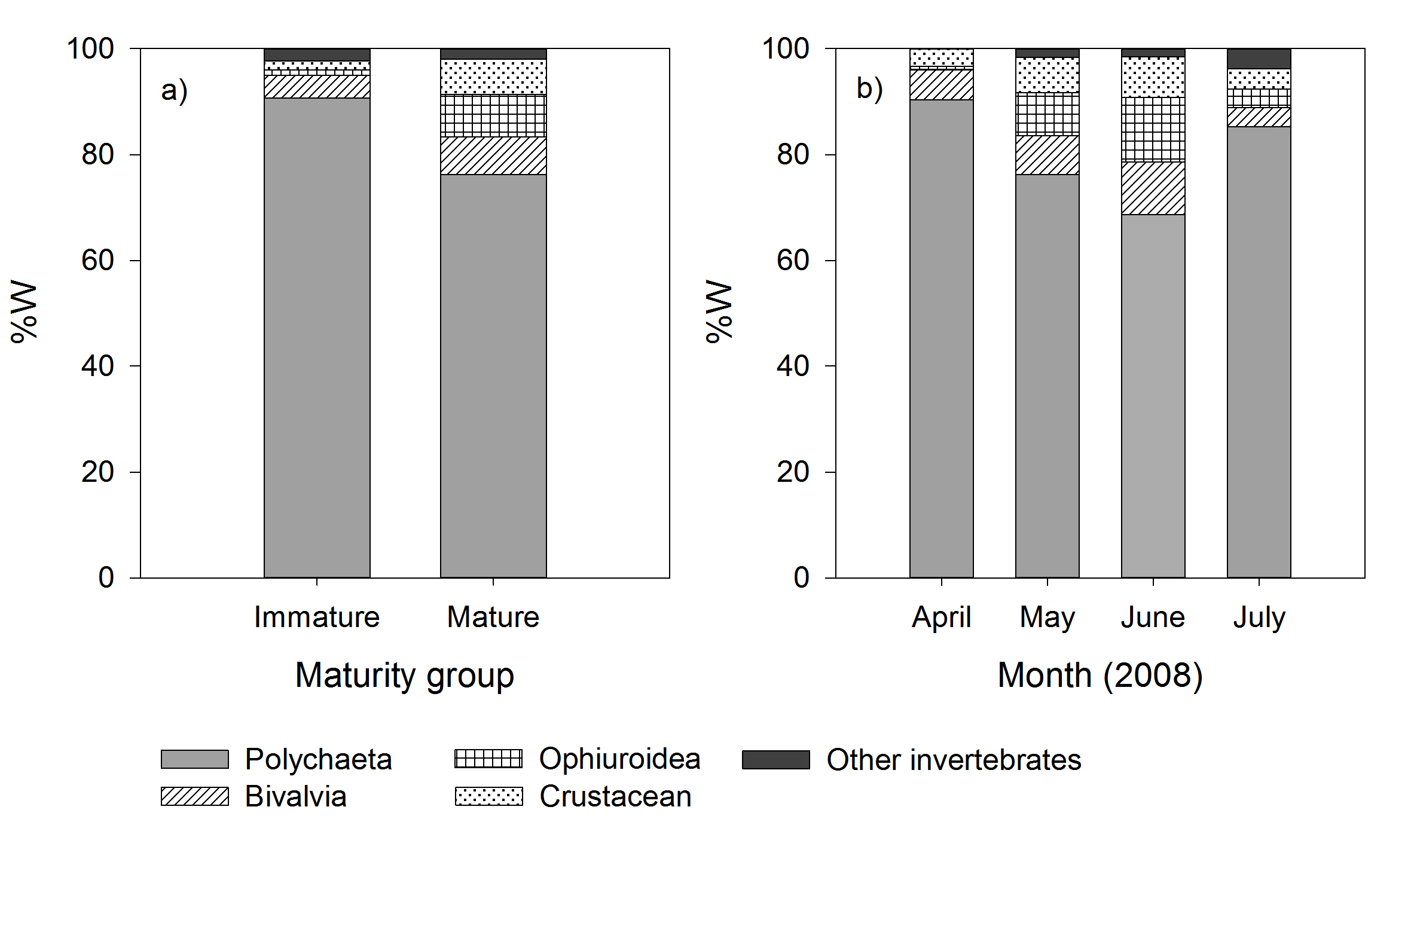
Fig. 2. Percentage mass contributions of the different dietary components of a) two maturity groups and b) four months for Pseudopleuronectes yokohamae in coastal waters of mid-western Korea.

In the DISTLM test, marginal test revealed that the diet of P. yokohamae was significantly (P <0·05) correlated with total length and maturity, whereas the diet was significant with total length and water temperature by conditional test (Table 2). The most parsimonious model included total length, month and water temperature. Although the effects of three predictors were significant (p<0.05), the model explained only 7.6% of the data variability (conditional test), indicating the majority of the variability in the diets could not be explained by the available predictors.
SIMPER emphasized that polychaetes were present in relatively greater contributions in the diets of smaller than larger P. yokohamae, whereas the opposite trend was true for ophiuroids and bivalves. Among prey taxa, ophiuroids and bivalves were contributed mostly to the dissimilarity between small and large size classes.

Table 2. Results of distance-based linear modeling (DISTLM) analysis relating Pseudopleuronectes yokohamae diet with total length, maturity, month, water temperature and sex, individually (marginal test) and sequentially (conditional test), for a population from the mid-western coast of Korea.
Predictor variables | Pseudo-F | R² | P | Prop.
Marginal test
Month | 1.503 |  | 0.199 | 0.008
Temperature | 1.527 |  | 0.214 | 0.008
TL | 6.536 |  | 0.001 | 0.033
Maturity | 5.685 |  | 0.001 | 0.029
Sex | 1.251 |  | 0.292 | 0.006
Conditional test
+TL | 6.536 | 0.033 | 0.001 | 0.033
+Month | 2.215 | 0.044 | 0.084 | 0.011
+Temperature | 6.693 | 0.076 | 0.001 | 0.032

Discussion

Based on the %IRI values (Table 1), P. yokohamae was carnivorous fish that consumed various benthic invertebrates. The greatest contributors in the diets of P. yokohamae were polychaetes, with the majority being benthic thus suggesting foraging close to the surface and/or inside of the substratum. Diets of P. yokohamae reported here are comparable to those reported for other species of flatfishes elsewhere. The importance of polychaetes in the diets was also reported for some other flatfishes globally (e.g. Link et al., 2002; Dou, 1995; Vinagre et al., 2008), however this prey taxa was not common food for most of righteye flounders. For example, among co-occurring six Pleuronectidae fishes in the northwestern Atlantic, Glyptocephalus cynoglossus and Limanda ferruginea consumed mainly polychaetes, but other flounders ingested various benthic and/or benthopelagic food items (Link et al., 2002). In the Bohai Sea, the dominance of polychaetes in the diets of flatfishes were relatively low based on percentage weight, indicating lower importance for food items than other benthic invertebrates and teletosts (Dou, 1995). Nonetheless, polychaetes are considered to be a fundamental food resources at least for some righteye flounders (Zhang, 1988; Link et al., 2002; Vinagre et al., 2008), and also some other benthic fishes (Labropoulou and Eleftheriou, 1997; Garrison and Link, 2000).
There were region-specific differences in food resources for P. yokohamae in Korean waters. P. yokohamae from the coastal waters off Tongyeong (southeastern Korea) fed mainly on bivalves, secondly polychaetes based on %W (Huh et al., 2012), whereas relatively smaller fishes inhabiting eelgrass bed in southern coast consumed mainly polychaetes and amphipods (Kwak and Huh, 2003). In the Sendai Bay of Japan, polychaetes were major component of dietary composition for P. yokohamae, while bivalve and sea anemones also contributed moderately in the diets of P. yokohamae (Omori, 1974). From the above, it appears that P. yokohamae preferred polychaetes as their main food, but bivalves were only abundant in the diets of its southeastern population, Korea (Huh et al., 2012). These differences due to dominance of bivalves (mainly blue mussel, Mytilus edulis) versus polychaetes in the diets of P. yokohamae between different sea, thus showing different benthic faunal compositions. Generally, fish target the most abundant locally available prey and such behaviour may be influenced by the catch success rate and/or the probability of encountering prey (Persson and Diehl 1990).
In the present, there was unusually feeding behaviour for P. yokohamae, i.e. frequent consumption of ophiuroids. Bottom-feeding carnivores often use ophiuroids as a minor food source (Dou 1995; Gonzales et al. 1996; Jaworski and Ragnarsson 2006), while only a few species are known to specialize in ophiuroids (Jewett and Feder 1980; Gabriel and Pearcy 1981; Ohmura et al. 2005; Baeck et al., 2011b). Nonetheless, it still remains uncertain question why certain fish species specialize in prey items which appear to be difficult to digest and have low energy content. Ohmura et al. (2005) suggested that this specialized foraging strategy seems to reduce intra- and interspecific competition for food between co-occurring fish species. However, this hypothesis is not sufficient to explain this foraging strategy, thus further research incorporating importance of ophiuroids as a food for those species is needed to assess this.
Ontogenetic diet changes are common in fish species and are usually related to maximizing energy intake (Gerking, 1994). The diets of many species are segregated by life history stage, allowing larger individuals to do not directly compete with smaller conspecific individuals for food resources or habitats (Langton, 1982; Chizinski et al., 2007). Stomach contents analysis showed that dietary composition of P. yokohamae changed significantly as predator size increase. Although polychaetes were major dietary component of both immature and mature groups, immature P. yokohamae mostly focused on polychaetes, whereas mature individuals targeted more ophiuroids and bivalves. This increase, in particular the contribution of the robust prey (i.e. ophiuroids and bivalves), may be partly explained by the increase of ability to capture and digest these prey as they grow, because larger fish may have increased ability to crush hard-bodied prey than smaller conspecifics (Wainwright 1988).
Diet of P. yokohamae did not significantly vary between sexes. Although some flatfishes showed differences in diet between sexes (Molinero and Flos 1991), many of these fishes represented similar dietary composition between sexes (e.g. Castillo-Rivera et al. 2000; Amezcua et al. 2010). These are probably because males and females did not show spatial or seasonal habitat segregation.
True seasonal changes could not be assessed in this study due to the lack of seasonal replication and samples covering all seasons. Seasonal changes in fish feeding habits are associated with changes in food availability caused by environmental factors and physiological variation (Wootton 1990). In the present study, P. yokohamae principally consumed polychaetes in all months, thus no marked difference were observed in the diets between months, although there were some increased consumption of ophiuroids and bivalves during May and June. Nonetheless, due to the lack of information on all season data, our data did not show true temporal diet changes. Further studies are demanded to discover dietary habits of P. yokohamae in detail.
In conclusion, this study offers important insights into the diets of P. yokohamae that are abundant in the mid-western coast of Korea. Stomach contents indicated that they consumes mainly polychaetes, regardless of size, sex or month. Some ontogenetic and temporal changes in diets were also observed. Nonetheless, a lack of samples covering wider regions, all possible size ranges and/or all seasons imposed limitations on describing absolute diets of the species throughout their entire life histories. Studies on dietary habits of P. yokohamae are essential to understand prey-predator relationships in benthic ecosystems, and are important baseline studies for management and conservation efforts in western Korean sea.

Acknowledgments
This research was funded by the Korea Inter-University of Ocean Science at Pukyong National University, Korea. We are indebted to Dr. Hee Chan Choi for their assistance in sample collection. Fish used in this study were by-catch from field surveys conducted by Pukyong National University. Field surveys were conducted under approval of “Research & Training Fishery” in Ministry of Ocean and Fisheries, Korea

References
Amezcua F, Portillo A, Amezcua-Linares F (2011) Feeding habits of the toothed flounder Cyclopsetta querna (Paralichthyidae) of the south-east Gulf of California. J Mar Biol Assoc UK 91: 1225–1230.
Anderson MJ, Gorley RN, Clarke KR (2008) PERMANOVA+ for PRIMER: Guide to Software and Statistical Methods. PRIMER-E, Plymouth Marine Laboratory, Plymouth, UK.
Baeck GW, Park C-I, Choi HC, Huh SH, Park JM. (2011a). Feeding habits of ocellate spot skate, Okamejei kenojei (Müller & Henle, 1841), in coastal waters of Taean, Korea. J Appl Ichthyol, 27, 1079-1085.
Baeck, G. W., Park, J. M., & Hashimoto, H. (2011b). Feeding ecology of three tonguefishes, genus Cynoglossus (Cynoglossidae) in the Seto Inland Sea, Japan. Animal Cells and Systems, 15(4), 325-336.
Brodeur RD, Pearcy WG (1992) Effects of environmental variability on trophic interactions and food web structure in a pelagic upwelling ecosystem. Mar Ecol Prog Ser 84: 101–119.
Castillo‐Rivera BM, Kobelkowsky A, Chavez AM (2000) Feeding biology of the flatfish Citharichthys spilopterus (Bothidae) in a tropical estuary of Mexico. J Appl Ichthyol 16: 73–78.
Cha, B. Y., Im, Y. J., Jo, H. S., & Kwon, D. H. (2013). A fish community caught by a stow net in the water off Hwanseong city, the west sea, Korea. Kor J Ichthyol, 25, 119-134.
Chizinski CJ, Huber CG, Longoria M, Pope KL (2007) Intraspecific resource partitioning by an opportunistic strategist, inland silverside Menidia beryllina. J Appl Ichthyol 23: 147–151.
Dou S. 1995. Food utilization of adult flatfishes co-occurring in the Bohai Sea of China. Neth J Sea Res. 34: 183-193.
Dunn, M. R. (2009). Feeding habits of the ommastrephid squid Nototodarus sloanii on the Chatham Rise, New Zealand. New Zealand Journal of Marine and Freshwater Research, 43(5), 1103-1113.
Ferry LA, Cailliet GM (1996) Sample size and data analysis: are we characterizing and comparing diet properly? In: MacKinlay D, Shearer K (eds) International congress on the biology of fishes, San Francisco, California, pp 71–80.
Froese R, Pauly D (2015) FishBase. 2015. World Wide Web electronic publication. Available at: www.fishbase.org (accessed on 25 April 2015).
Gabriel WL, Pearcy WG. 1981. Feeding selectivity of dover sole, Microstomus pacificus, off Oregon. Fish Bull. 79: 749-763.
Garrison, L. P., & Link, J. S. (2000). Dietary guild structure of the fish community in the Northeast United States continental shelf ecosystem. Marine Ecology Progress Series, 202, 231-240.
Gerking SD (1994) Feeding Ecology of Fish, Academic Press, San Diego.
Gonzales BJ, Taniguchi N, Okamura O, Machida Y. 1996. Diet and feeding of two gragonets, Calliurichthys japonica and Repomucenus huguenini in Tosa Bay, Southern Japan. Fish Sci. 62: 902-908.
Greenstreet SP, Rogers SI (2006) Indicators of the health of the North Sea fish community: identifying reference levels for an ecosystem approach to management. ICES J Mar Sci 63: 573–593. http://dx.doi.org/10.1016/j.icesjms.2005.12.009.
Huh SH, Baeck GW. 2003. Feeding habits of Hippoglossoides pinetorum collected in the coastal waters of Kori, Korea. Korean J Ichthyol, 15, 157-161.
Huh SH, Nam KM, Park JM, Jeong JM, Baeck GW. 2012. Feeding habits of the marbled flounder, Peluronectes yokohamae in the coastal waters off Tongyeong, Korea. Kor J Ichthyol, 24, 77-83.
Huveneers C, Otway NM, Gibbs SE, Harcourt RG (2007) Quantitative diet assessment of wobbegong sharks (genus Orectolobus) in New South Wales, Australia. ICES J Mar Sci 64: 1272–1281.
Jaworski A, Ragnarsson SA. 2006. Feeding habits of demersal fish in Icelandic waters: a multivariate approach. ICES J Mar Sci. 63:1682 1694.
Jeong G-S, Cha B-Y, Im Y-J, Kwon D-H, Hwang H-J and Jo H-S. (2014). Comparison of species composition and seasonal variation of demersal organisms caught by otter trawl in the coastal waters off the Taean peninsula, in the west sea of Korea. Korean Journal of Fisheries and Aquatic Sciences, 47: 264-273.
Jewett SC, Feder HM. 1980. Autumn food of adult starry flounders, Platichthys stellatus, from the northeastern Bering Sea and the southeastern Chukchi Sea. ICES J Cons. 39:7 14.
Joh, M., Takatsu, T., Nakaya, M., Higashitani, T., & Takahashi, T. (2005). Otolith microstructure and daily increment validation of marbled sole (Pseudopleuronectes yokohamae). Marine Biology, 147(1), 59-69.
Kim, H., Huh, S., Kim, S., & Seo, Y. I. (2015). Age and Growth of Marbled sole, Pleuronectes yokohamae (Günther) in the southern waters of Korea. Journal of the Korean society of Fisheries Technology, 51(1), 35-41.
Kim IS, Choi Y, Lee CL, Lee YJ, Kim BJ, Kim JH (2005) Illustrated book of Korean fishes. Kyo-Hak Publishing Co., Seoul, Korea.
Kim, S. Y., Im, Y. J., Jo, H. S., Cha, B. Y., Kwon, D. H., & Hwang, H. J. (2013). Fishing Characteristic of Beam Trawl Fishery in the Coastal Waters of Chungnam Province, Korea. Journal of the Korean Society of Marine Environment & Safety, 19(5), 459-466.
KOSTAT (1990–2015) Fishery Production Survey. Statistic Korea. Available at: www.kostat.go.kr (accessed on 6 June 2016).
Kwak SN, Huh SH. 2003. Feeding habits of Limanda yokohamae in the eelgrass bed (Zostera marina) bed in Kwangyang Bay. J Kor Fish Soc, 36, 522-527.
Labropoulou, M., & Eleftheriou, A. (1997). The foraging ecology of two pairs of congeneric demersal fish species: importance of morphological characteristics in prey selection. Journal of Fish Biology, 50(2), 324-340.
Langton RW (1982) Diet overlap between Atlantic cod, Gadus morhua, silver hake Merluccius bilinearis and fifteen other northwest Atlantic finfish. Fish Bull 80: 745–759.
Link JS, Bolles K, Milliken CG (2002) The feeding ecology of flatfish in the northwest Atlantic. J Northw Atlantic Fish Sci 30: 1–17.
Micheli F, Halpern BS (2005) Low functional redundancy in coastal marine assemblages. Ecology Letters 8, 391–400
Molinero A, Flos R (1991) Influence of sex and age on the feeding habits of the common sole Solea solea. Mar Biol 111: 493–501.
Moon HT, Lee TW. (1999). Age and growth of juvenile Limanda yokohamae in the shallow water off Gaduk-do as indicated from microstructure in otoliths. Kor. J. Ichthyol, 11: 46-51.
Nam KM, Huh SH, Heo YS, Jeong JM, Kim HJ, Baeck GW. 2013. Stomach contents of the stone flounder, Kareius bicoloratus and roughscale flounder, Clidoderma asperrimum in the coastal waters off Tongyeong, Korea. Korean J Ichthyol, 25, 163-168.
NFRDI (2004) Commercial fishes of the coastal and offshore waters in Korea. Hangel, Busan. Korea.
Ohmura T, Hamatsu T, Takahashi T. 2005. Food habits of kichiji rockfish Sebastolobus macrochir in summer on the continental slope off the Pacific coast of Hokkaido, Japan. Nippon Suisan Gakkaishi, 71:584-593. (in Japanese)
Omori, M. (1974). On the production ecology of the flatfish, Limanda yokohamae, 1: Feeding habit and distribution [Sendai bay, Japan]. Bulletin of the Japanese Society of Scientific Fisheries.
Park, J., Jo, H. S., Im, Y. J., Cha, B. Y., Kwon, D. H., Ryu, D. K., & Hwang, H. J. (2013). Species composition and community structure caught by shrimp beam trawl in the marine ranching ground of Taean, Korea. Journal of the Korean society of Fisheries Technology, 49: 238-249.
Persson L, Diehl S. 1990 Mechanistic individual-based approaches in the population/community ecology of fish. In Annales Zoologici Fennici (pp. 165-182). Finnish Zoological Publishing Board, formed by the Finnish Academy of Sciences, Societas Scientiarum Fennica, Societas Biologica Fennica Vanamo and Societas pro Fauna et Flora Fennica.
Pinkas L, Oliphant MS, Iverson ILK. 1971. Food habits of albacore, bluefin tuna and bonito in California waters. Fishery Bulletin, 152: 1–105.
Platell ME, Potter IC. 2001. Partitioning of food resources amongst 18 abundant benthic carnivorous fish species in marine waters on the lower west coast of Australia. Journal of Experimental Marine Biology and Ecology, 261: 31–54.
Seo YI, Joo H, Lee SK, Kim H, Ko JC, Choi MS, Kim JI, Oh TY. 2010. Maturity and spawning of marbled sole Pleuronectes yokohamae in the southern sea of Korea. Korean Journal of Ichthyology, 22: 83-89.
Tanda M, Nakamura Y, Okamoto S. 2008. Maturity and spawning season of marbled sole Pleuronectes yokohamae, and comparison of reproductive characters between different survey periods in Harima Nada and Osaka Bay, the Seto Inland Sea, Japan. Bulletin of the Japanese Society of Fisheries Oceanography (Japan), 72, 273-281
Vinagre C, Cabral H, Costa MJ. 2008. Prey selection by flounder, Platichthys flesus, in the Douro estuary, Portugal. Journal of Applied Ichthyology, 24, 238-243.
Wainwright PC. 1988. Morphology and ecology: Functional basis of feeding constraints in Caribbean labrid fishes. Ecology 69: 635-645.
Wootton RJ. 1990. Ecology of Teleost Fishes. Champman Holl, New York, USA.
Yamada U, Tagawa M, Kishida S and Honjo K. 1986. Fishes of the East China Sea and the Yellow Sea. Seikai Reg Fish Res Lab, 501.
Zhang CI. 1988. Food habit and ecological interactions of Alaska plaice, Pleuronectes quadrituberculatus, with other flatfish species in the eastern Bering Sea. Bull Korea Fish Soc, 21, 150-160.

